**Graphic representation of speech signals**

**Objective:** To create a function that would read a speech signal from an audio file, allow the user to select a segment of the signal, and graphically display these signals.

**MATLAB functions:** uigetfile, uiputfile, inputdlg, questdlg, msgbox, audioread, audiowrite, audioinfo, input, disp, subplot, plot, grid, axis, xlabel, ylabel, title, linspace, length, size.

**Requirements for the function:**

1. A file (*.wav type) with an audio recording is selected using the standard file selection dialog (uigetfile function).
2. The function should read and correctly graphically present a signal of any quality. The signal should be presented as a continuous function of time, the time axis scale should be in milliseconds. In the case of a stereo recording, each channel is presented separately.
3. The function must output information about the quality of the scanned recording: sampling rate, number of channels, and number of quantization bits.
4. The function must ask for the start and end of the segment in milliseconds and graphically display the specified segment. The signal segment must be displayed on a new graphical plane as a continuous function of time, the time axis scale must be in milliseconds (starting from 0). The graphs are displayed in a column, i.e. one after the other (see figure).

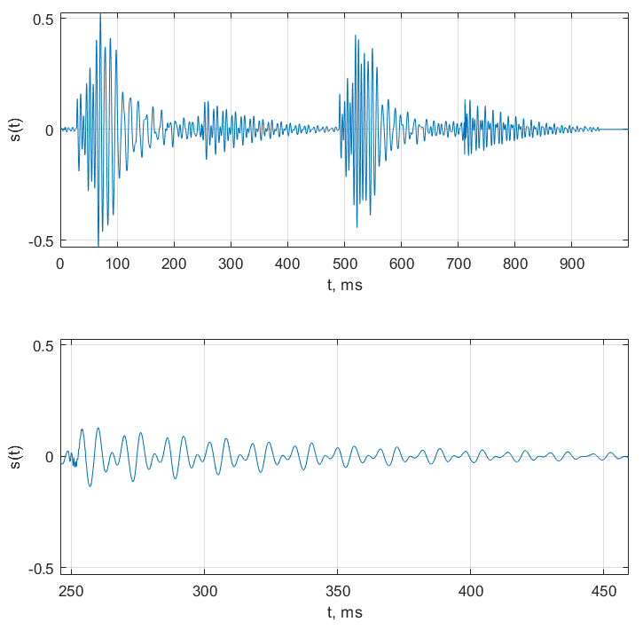

1. The function should offer the user to save the selected section to a *.wav file (using the standard file save dialog – the uiputfile function). The file is saved in the same quality as the original recording.

Prepare and submit a report for assessment (in the Moodle system). Report content:

* Cover information: name and surname of the student who completed the work, groups, work number and title.
* Purpose of the work.
* Work results:
  + Graphical results: time diagrams of speech segments
  + Information about the quality of the scanned recording
* Summary, conclusions.
* Developed program code (provided as an attachment).

The report must be submitted by the end of the semester 2025-05-23. If the report is submitted late, the work grade will be reduced.